Genus Salmonella

Morphology: قيل سابقا

Gram negative rods, non spore-forming, motile with peritrichous flagella except S. Pullorum and S. Gallinarum

Culture characteristics: قيل سابقا
• Facultative anaerobes and grow optimally at 37°C.
• On MacConkeys agar media, it produces pale yellow colonies.
• On Bismuth sulphate agar, it produces brown to black colonies.
• Can be isolated on other media as Salmonella Shigella (SS) agar, Brilliant Green (BG) and Xylose-lysine Deoxycholate (XLD) agar.
هذه الميديات الأخرى مطلوب الأسماء فقط ولو إختصاراتها فقط

Biochemical reaction: قيل سابقا
• Oxidase negative, catalase positive and reduce nitrate to nitrite.
• Do not ferment lactose while ferment glucose, maltose and mannitol with production of acid and gas. On TSI, it produces yellow (acidic) butt and red slant (alkaline). Some serotypes produce black butt due to production of H₂S.
• Urease negative.
• Some serotypes produce H₂S.
• IMVC Test: -Ve +Ve -Ve +Ve

Classification of Salmonella:
يوجد تصنيفان للسالمونيلا
واحد قديم هو أسمه Kauffman-white classification أو traditional classification
، والأخر حديث أسمه DNA-DNA hybridization studies أو Advanced classification

  - Kauffman-white classification (traditional classification):

Based on somatic (O) and flagellar (H) antigens present in Salmonella, there are about 2500 serotypes of Salmonella.
فى السالمونيلا بقول serotypes Salmonella وليس Spp. Salmonella
فى هذا التصنيف بلاقى كل serotypeكما موضح بالجدول (يكتفى بمثال واحد)

According to somatic (O) antigen, Salmonella are classified to serogroups, designated by large alphabetic letter from A to G and the somatic (O) antigens of serotype are given Arabic numbers.

The flagellar (H) antigens are detected in two antigenic forms known as phase I and phase II. Phase I is the specific while phase II is non-specific. Phase-I flagellar antigens are designated by small alphabetic letter from a – z and phase-II H antigens are designated by Arabic numbers (1-12).

Serotype | Serogroup | Somatic (O) antigens | Flagellar (H) natigens
Serotype | Serogroup | Somatic (O) antigens | Phase 1 | Phase II
Salmonella Typhimurium | B | 1,4, 5, 12 | i | 1,2
Salmonella Enteritidis | D₁ | 1,9, 12 | g, m | 1,7
Salmonella Dublin | D₁ | 1,9, 12, [Vi] | G,P | -
Salmonella Gallinarum | D₁ | 1,9, 12 | - | -
Salmonella Pullorum | D₁ | 9, 12 | - | -

  - DNA-DNA hybridization studies classification (Advanced classification):

DNA-DNA hybridization studies demonstrated that genus Salmonella can be divided into two species are Salmonella enterica and Salmonella bongori.
    - Salmonella enterica is divided into six subspecies are Enterica, Arizona, Diarizona, Indica, Houtenae and Salamae. Salmonella enterica contains most Salmonella serotypes (about 2448 serotypes). Subspecies enterica contains the most important serotypes.
    - Salmonella bongori contains low number of serotypes.

Diseases caused by Salmonella serotypes:-
  - S. Pullorum causes Pullorum disease in chicks of up to 3 weeks old. Pullorum disease is characterized by white diarrhea, omphalitis (التهاب السرة)and sudden death with mortality rate 95- 100 %.
هذا المرض من الأمراض المهمة وبيتشاف كتير فى المزارع فى الأيام الأولى من دورة التربية ولذلك أصحاب المزارع بيدوا الكتاكيت مضاد حيوى أسمه الكولستين أو فلوروفنيكول للوقاية منه
بيحدث نتيجة شراء كتاكيت مصابة بالميكروب من الأمهات والمفرخات لأن الأمهات بتكون حاملة لهذا النوع من البكتريا وبيحصل egg transmitionوتلوث للمفرخات
  - S. Gallinarum causes Fowl typhoid in adult birds. Fowl typhoid is characterized with greenish or yellow diarrhea and death with mortality rate 50 %.
هذا المرض من الأمراض المهمة وبيتشاف كتير فى المزارع أيضا
  - S. Arizona causes Arizona (entritis, arthritis and meningitis) in Turkey.
  - S. Dublin, S. Typhimurium, S. Newport, and S. Abortus causes Salmonellosis in young calves. It is characterized by diarrhea, septicaemia and death.
  - S. Dublin and S. Typhimurium causes Entritis in sheep and goat.
  - S. Abortus causes abortion in cows, sheep, goat and equines.
  - S. Typhi, S. Paratyphi A and S. Paratyphi B causes typhoid and paratyphoid fever (Enteric fever) in Human.
التيفود والحمى التيفودية من الأمراض المهمة فى الأنسان واللى هيشتغل فى معمل تحاليل هيشوفها كتير وهيجله تحليل فيدال (Widal test) لتشخيصهما بتلاقى المريض بيعانى من
Fever, Sever abdominal pain after eating contaminated food, diarrhea
  - Many Salmonella serotypes as Salmonella Typhimurium and Salmonella Enteritidis cause Salmonella food poisoning or enterocolitis in Human.

Laboratory diagnosis of diseases caused by Salmonella serotypes:
1) Sampling: According to the infection
Enrichment step in case of stool sample
2) Microscopical examination
Not performed in case of diagnosis of GIT diseases where has no value.
3) Isolation and identification
4) Serological identification of the isolates by slide or tube agglutination test, LISA or IFT.
5) PCR.
6) Phage typing: for epidemiological studies.

Genus Proteus

Members of this genus are widely distributed in the natures. It includes two important species; Pr. vulgaris and Pr. mirabilis.

Morphology:

Gram negative pleomorphic rods, non-spore forming and highly motile.

Culture characteristics: قيل سابقا
• Facultative anaerobes.
• They can grow on ordinary media and blood agar showing swarming appearance due to their high motility.
• On MacConkeys agar media, it produces pale yellow colonies while the swarming appearance is inhibited by bile salts.

Biochemical reaction: قيل سابقا
• Oxidase negative, catalase positive and reduce nitrate to nitrite.
• Do not ferment lactose while ferment glucose with production of acid and gas. On TSI, it produces black butt (H₂S) and red slant (alkaline).
• Urease positive. Differentiates them from Salmonella and Shigella.
• Produce H₂S.

Diseases caused by Proteus species:-

Opportunistic pathogens frequently isolated from urinary tract infections in Human, dogs and cats. Also, it causes wound infections in animals and human.
Genus Yersinia

Rodents are the natural reservoirs of Yersiniae and less frequently the other mammals serve as a host for them.
Morphology: قيل سابقا

• Gram negative short bacilli, non-spore forming.
• Non-motile at 37° C but several species are motile at 25-29°C.
• With Geimsa stain, it has safety pin appearance (bipolar staining).

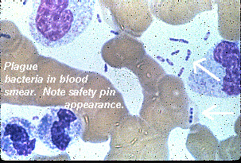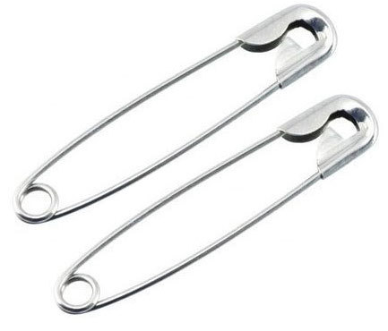

Culture characteristics: قيل سابقا
• Facultative anaerobes.
• Grow at wide range of temperature 25-37°C.
• On MacConkeys agar media, it produces pale yellow colonies.
• For improvement isolation of Yersinia from stool samples, Cold enrichment is made by making 5 % suspension of stool in phosphate buffer saline and its holding at 4°C for 3 weeks with subculturing weekly on MacConkey agar.
Cold enrichment بتتعمل فى ميكروبين ما هما ؟؟
Biochemical reaction: قيل سابقا
• Oxidase negative, catalase positive and reduce nitrate to nitrite.
• Do not ferment lactose while ferment glucose.
• Urease negative.

Important Yersinia species and diseases caused by them:-

- Y. ruckeri causes Enteric Redmouth diseases in fish. One of the septicemic diseases affecting marine water and freshwater fishes.
- Y. pestis causes plague (Black death) in human and cats. Transmitted from the rodents by fleas and it has three forms; Bubonic, Pneumonic and Septicemic. Y. pestis is used as biological warfare agent.
- Y. enterocolitica causes yersiniosis food poising in human.
- Y. pseudotuberculosis is primarily an animal pathogen cause UTI and fatal septicemia in animals. Occasionally affects human and causes fever and acute mesenteric lymphadenitis.

Shigellae produce bacillary dysentery in human.
Family Mycoplasmataceae
(Myces, a fungus; plasma, a form)
pleuropneumonia like organismsسميت قديما بـ
Mycoplasmas are the smallest prokaryotes (50-300 nm).
They lack the cell wall
ويترتب على ذلك
- They are extremely pleomorphic.
- Stained poorly with Gram stain.
- Resistant to cell wall inhibitors (β-lactam antibiotics), لا تعالج بهذه المضادات الحيوية .

Also, they are the only bacteria that contain sterols in their cell membrane, these sterols are not synthtized by the organism but acquired from the tissue or media where they grow.
لذا لابد أن أضيف sterolsفى الميديا الى هعزل عليها الميكوبلازما .

Morphology:

Small (50- 300 nm) pleomorphic microorganisms; greatly varing from coccoid bodies to branched filaments.
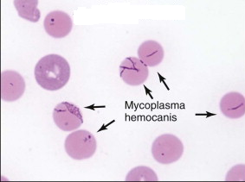

They are Gram-negative but poorly stained with Gram stain. They are usually non motile.

Culture and biochemical characteristics:

Mycoplasmas are fastidious microorganisms, require an enriched media for growth as PPLO agar (pleuropneumonia like organisms agar),
وبنضيف لهذه الميديا ما يلى
(1 Serum as a source for cholesterol.
2) Yeast extract as source for DNA and NAD.
3) Penicillin, thallous acetate and Amphotericin B to inhibit growth of Gram-positive bacteria, Gram-negative bacteria and fungi respectively.

Mycoplasmas are facultative anaerobes but they grow better in an atmosphere containing 5-10% CO₂. Their growth is slow requiring 2 to 7 days at 35- 37 °C.

On PPLO, Mycoplasmas produce round micro colonies (0.2-0.6mm) resemble Fried-egg appearance (زى بيض العيون).
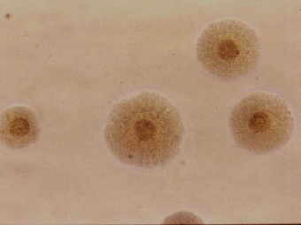

طيب ليه الكولنيز بتكون بالشكل ده لأنها زى ما واضح فى الرسم التوضيحي
with a dense opaque center (embedded in the agar) and a translucent peripheral zone.
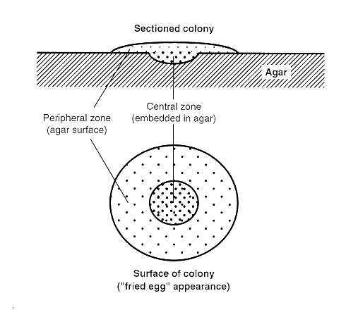

Biochemical tests used for identification of Mycoplasmas includes fermentation of glucose, hydrolysis of arginine, reduction of tetrazolium, liquefaction of coagulated serum and hydrolysis of casein.

Important Mycoplasma species and diseases caused by them:-

- M. mycoides subsp. mycoides causes contagious bovine pleuropneuronia (CBPP) in cattle. It is a highly contagious disease characterized by pneumonia and pleurisy in adults and arthritis in calves.
موجود فى المزارع
- M. bovis causes mastitis, arthritis and pneumonia in cattle.
- M. mycoides subsp. capri causes pneumonia, arthritis and septicaemia in sheep and goat
- M. agalactia causes mastitis in sheep and goat.
- M. gallisepticum cause chronic respiratory disease (CRD) and infectious sinusitis in chickens and turkeys. Complicated chronic respiratory disease (CCRD) occurs where the birds concurrently infected with E. coli, Newcastle disease virus, Infectious Bronchitis virus, or other pathogens.
من الأمراض المهمة الى بتحدث فى مزارع الدواجن ، الطيور بتتصاب بالميكوبلازما وبيحصل مرض الـ (CRD) ولما بتتصاب الطيور بميكروب أخر فى نفس الوقت زى الـ E. coli الحالة بتكون أسوا وبيسمى المرض CCRD
- M. meleagridis causes air sacculitis in turkeys.
- M. synovitis causes synovitis in chickens and turkeys.
- M. pneumoniae causes atypical pneumonia in human.

Laboratory diagnosis:
1) Sampling According to disease
The sample is frozen for isolation of the MOs.
2) Isolation and identification of causative agent
3) Identification of Mycoplasma strain by growth inhibition test
This test made by cultivation of Mycoplasma isolate on Mycoplasma media as PPLO then placing filter paper discs soaked with specific antisera against different Mycoplasma strains on surface of the inoculated media and then incubation of the inoculated media under the previously discussed conditions (Culture and biochemical characteristicsالللى اتذكرت فى ال) then the inspection macroscopically for presence zone of inhibition around these discs. Result is indicated by formation of inhibition zone around the disc containing the specific antiserum against the isolate.
4) Digitonin sensitivity test for differentiation of Mycoplasma from Acholeplasma
كفاية نعرف أسم الاختبار وإستخدامة فقط
5) Serological tests for
- Detection of Ag by IFT using specific antisera.
- Detection of Abs against Mycoplasma by ELISA, CFT and agglutination test.
6) PCR.

